Population Dynamics and Food Availability
(Module website http://web.as.uky.edu/Biology/faculty/cooper/Population%20dynamics%20examples%20with%20fruit%20flies/TheAmericanBiologyTeacher-PopulationDynamicsWebpage.html )

Introduction
We have already examined how initial population size affects how quickly a
population can grow. If you need a review of this material, please look over the material presented in the pupation and eclosion rate sections. Now, we turn to factors that limit not how quickly a population can grow but to how large it can grow. Every living thing has needs. Food, water, and shelter are examples. If food is limited, individuals in a
population have to compete for the same food source. In this portion of the module, we will design and execute an experiment to examine how food availability influences how large a population can grow.

Hypothesis Forming
Energy is essential for all life processes. Animals get their energy from food, so
food is also essential for animals to live. Since we are aiming to observe how limitations on food limit the size to which a population can grow, we should form a hypothesis as to what the relationship may be. Of the following hypotheses, which makes the most sense building on what you know about the importance of food? Why?
• Populations with more food will grow to a smaller size than similar populations with less food available.
• Populations with more food will grow to a larger size than similar populations with less food available.

Experimental Design
To test our hypothesis, we must design an experiment that varies our independent variable and allows us to quantify our dependent variable. Our independent variable (amount of food available) must vary across the experimental trials, and the dependent variable (size of the population) can then be assessed. All other variables should be held constant across the trials. For the following variables explain how you would keep them constant across trials:
• Water Availability
• Space (Volume) Availability
• Temperature
• Light Exposure
• Moisture

Procedure
Establishing Populations in Large Containers:
1. Obtain three storage containers (approximate volume of 1 gallon) with lids.
2. In each container, cut a small hole about a fourth of the way down in the middle.
Use the picture below for reference:
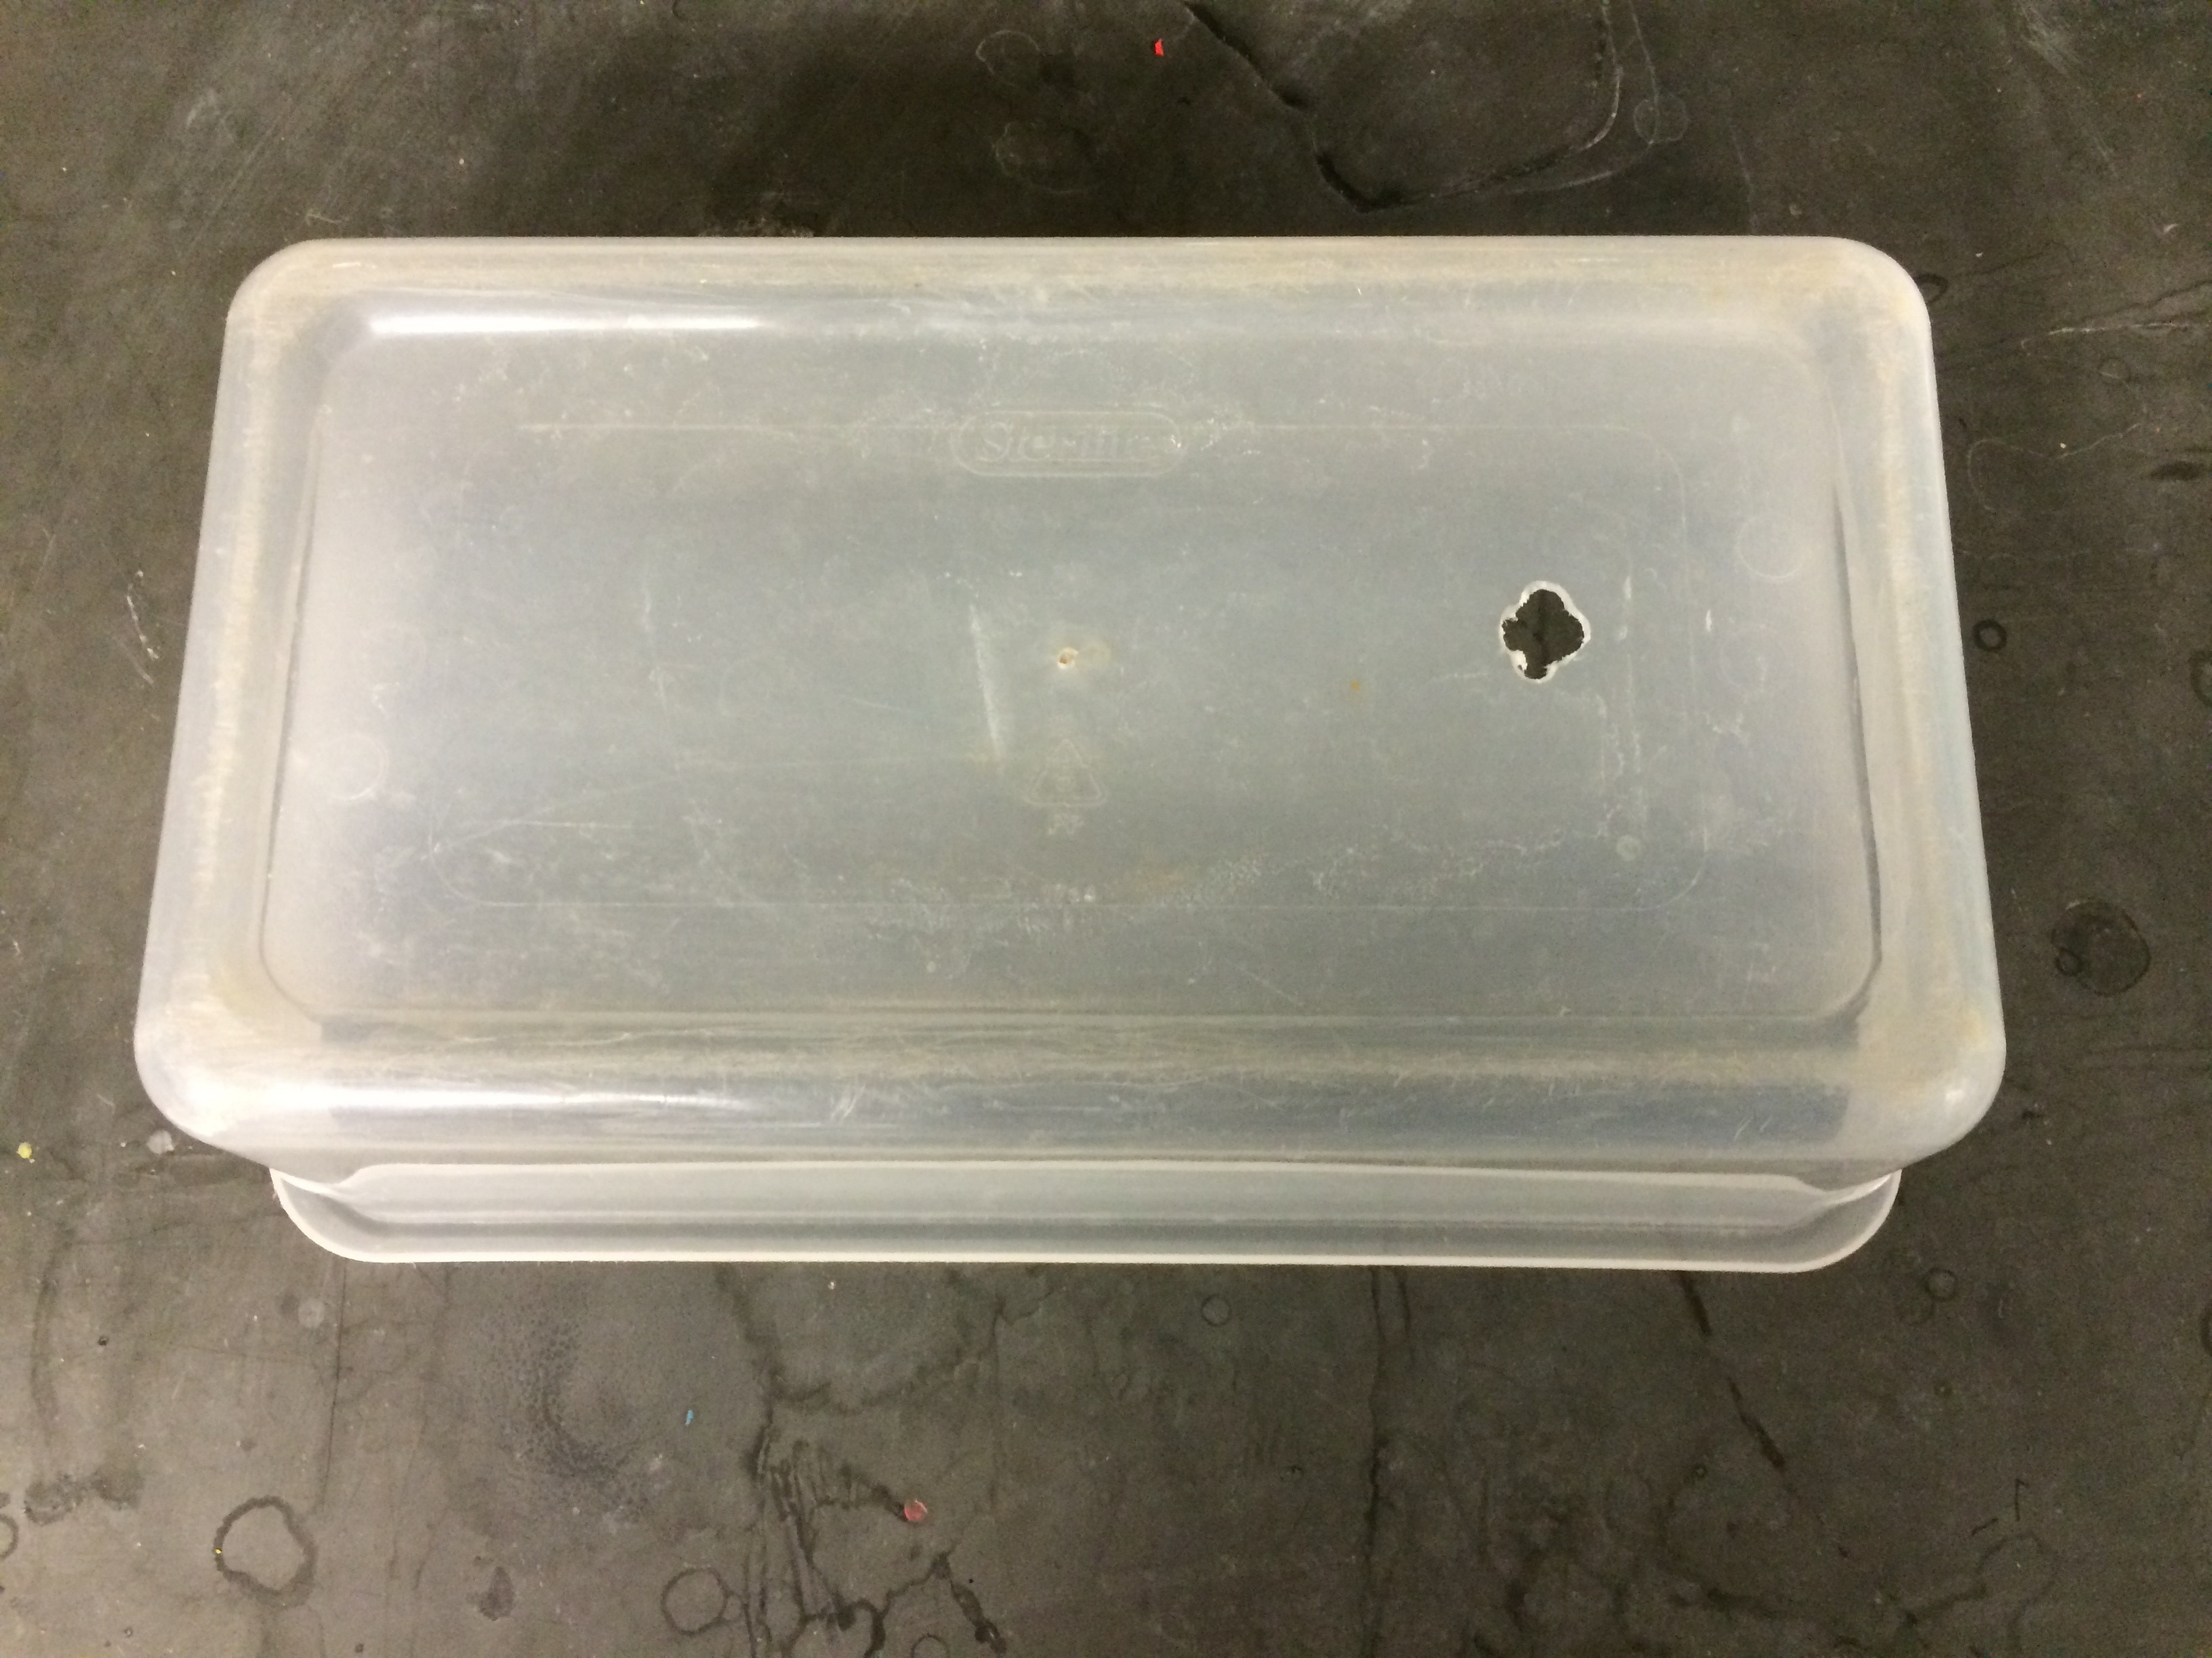

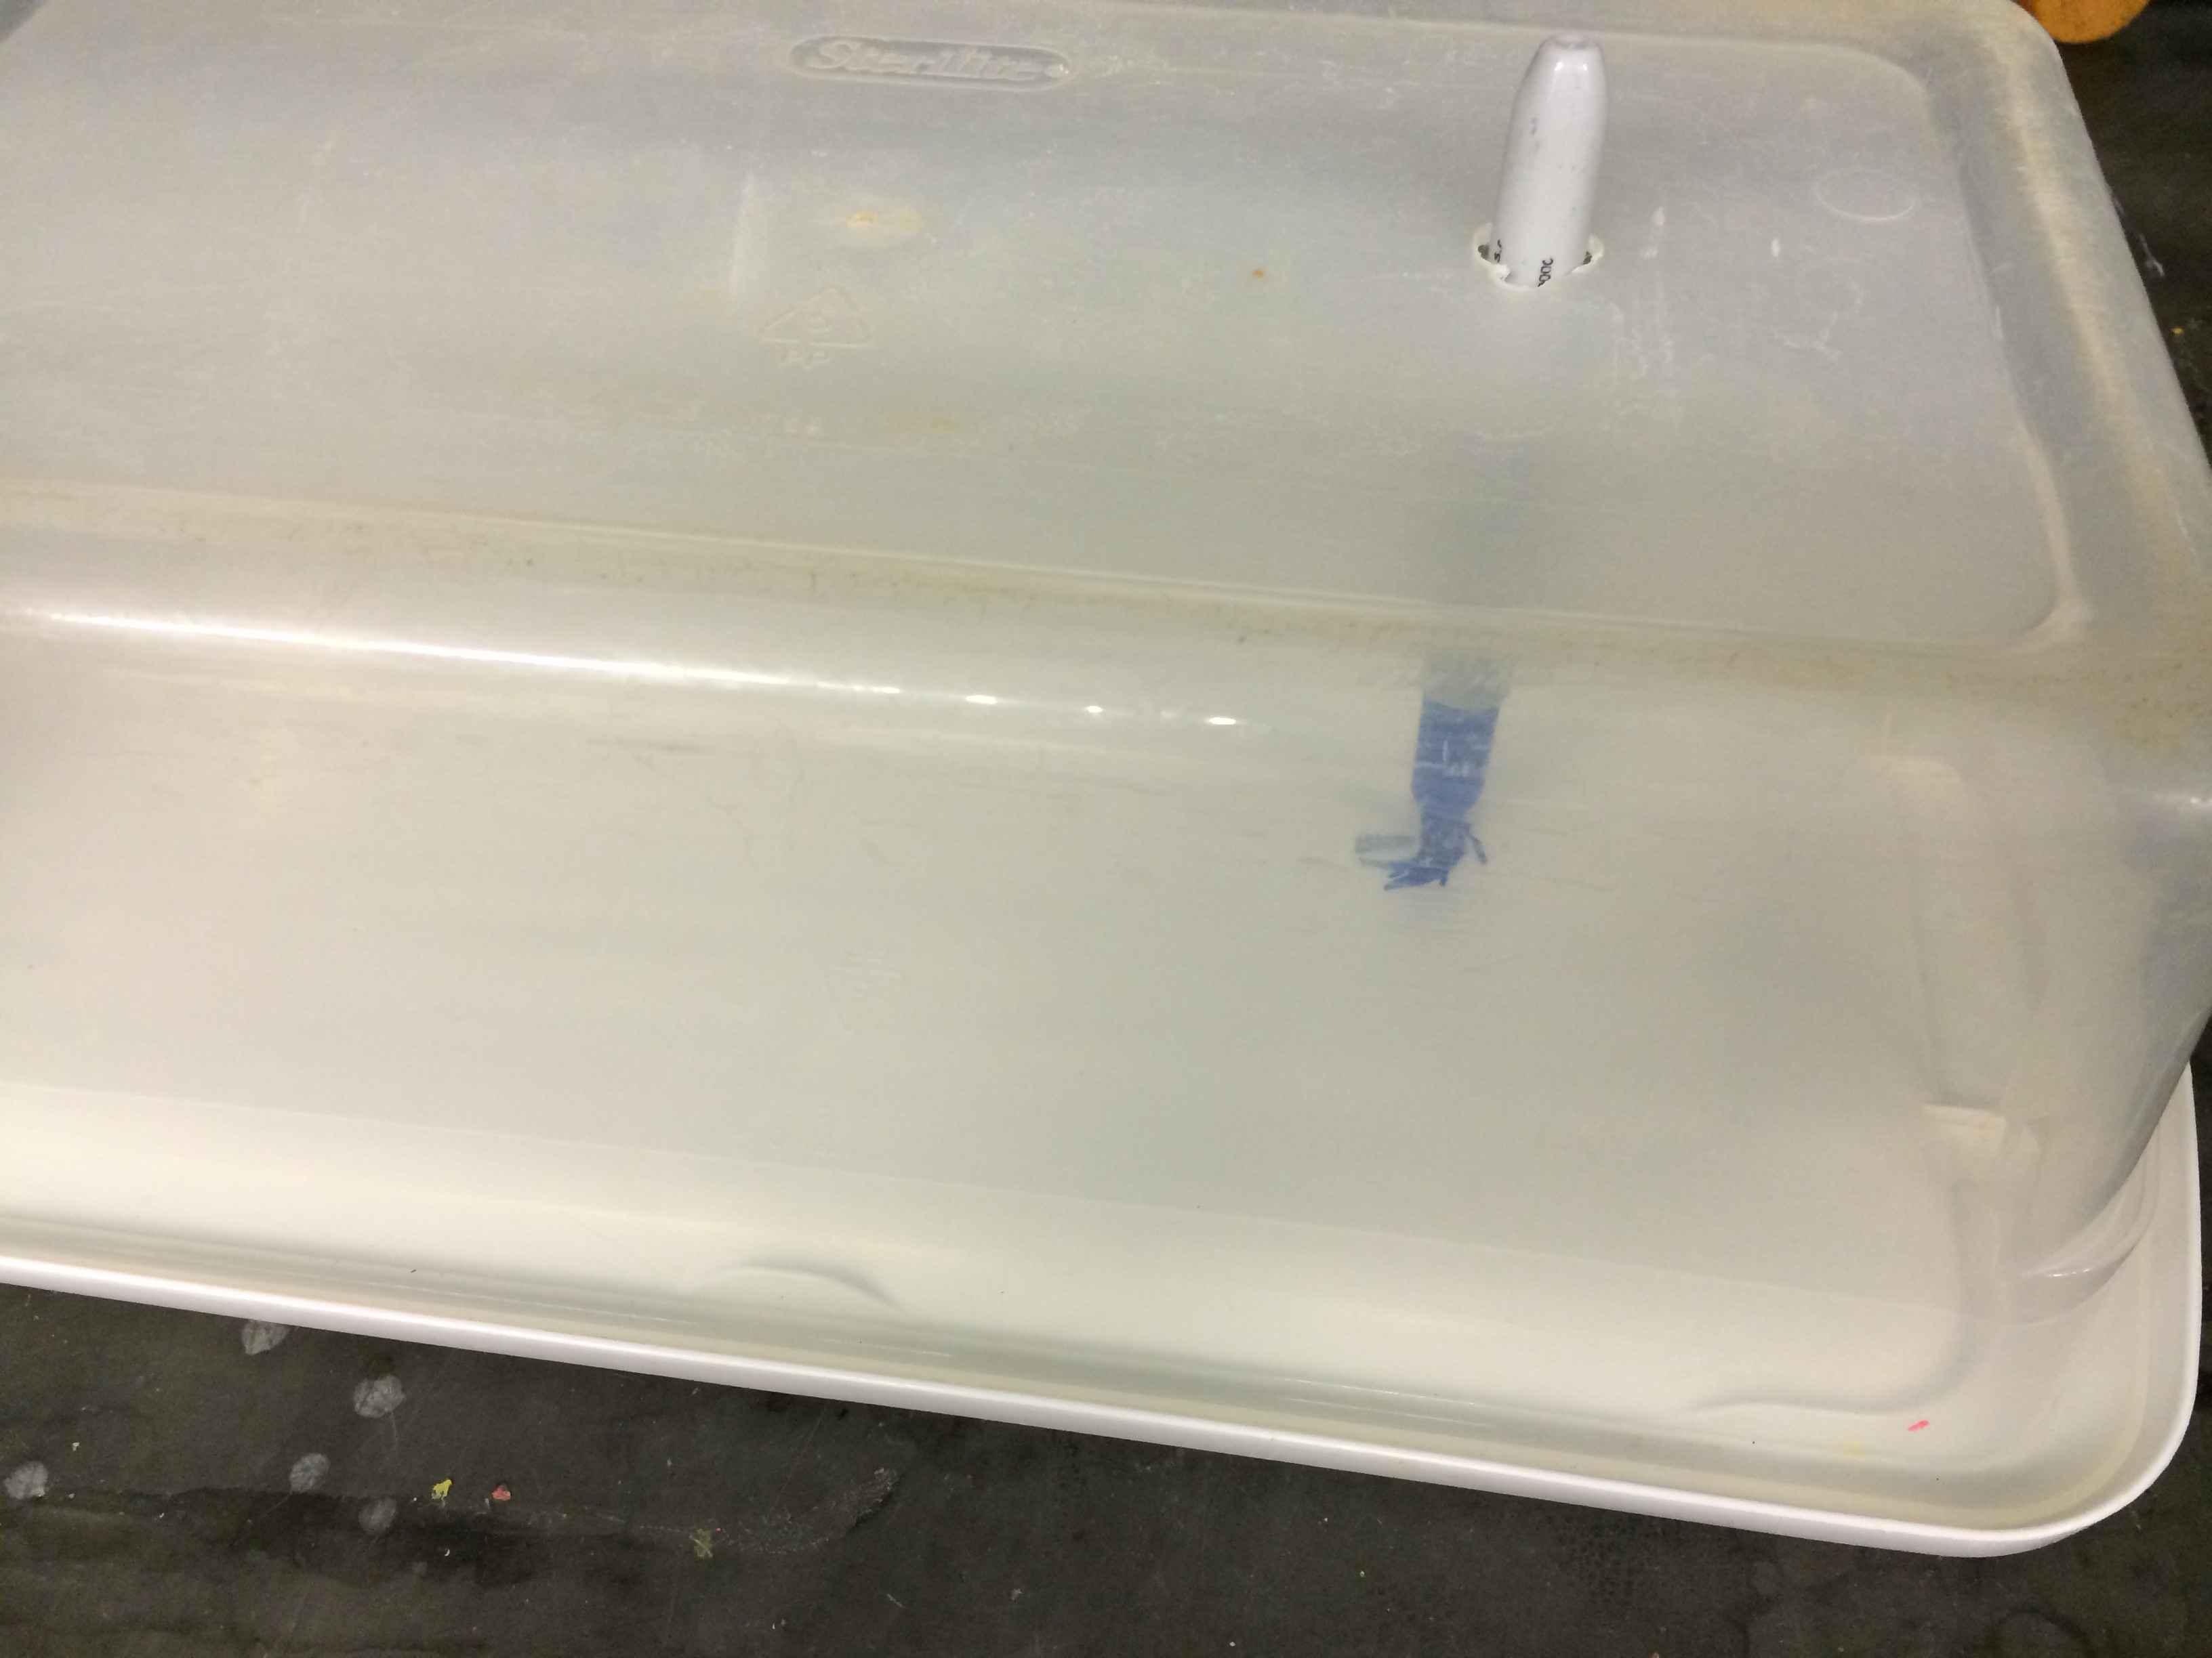3. On each lid, make a mark in permanent marker directly beneath the whole in the container. This can be seen in the image below:

4. Remove the container from the lid. Using a children’s modeling compound (such as Play-Doh), make a thin border around the edges of the lid. Try to follow the contours and lay the compound directly below where the lid will secure. The goal is to create an airtight barrier to prevent the flies from escaping.
5. Procure a jar, large petri dish, and piece of filter paper. Fill the jar with water, line the petri dish with the filter paper, and place the petri dish over the mouth of the jar. Invert the apparatus such that the water moistens the filter paper but doesn’t

flood the dish. Do this three times. These will serve as a water source during the experiment.
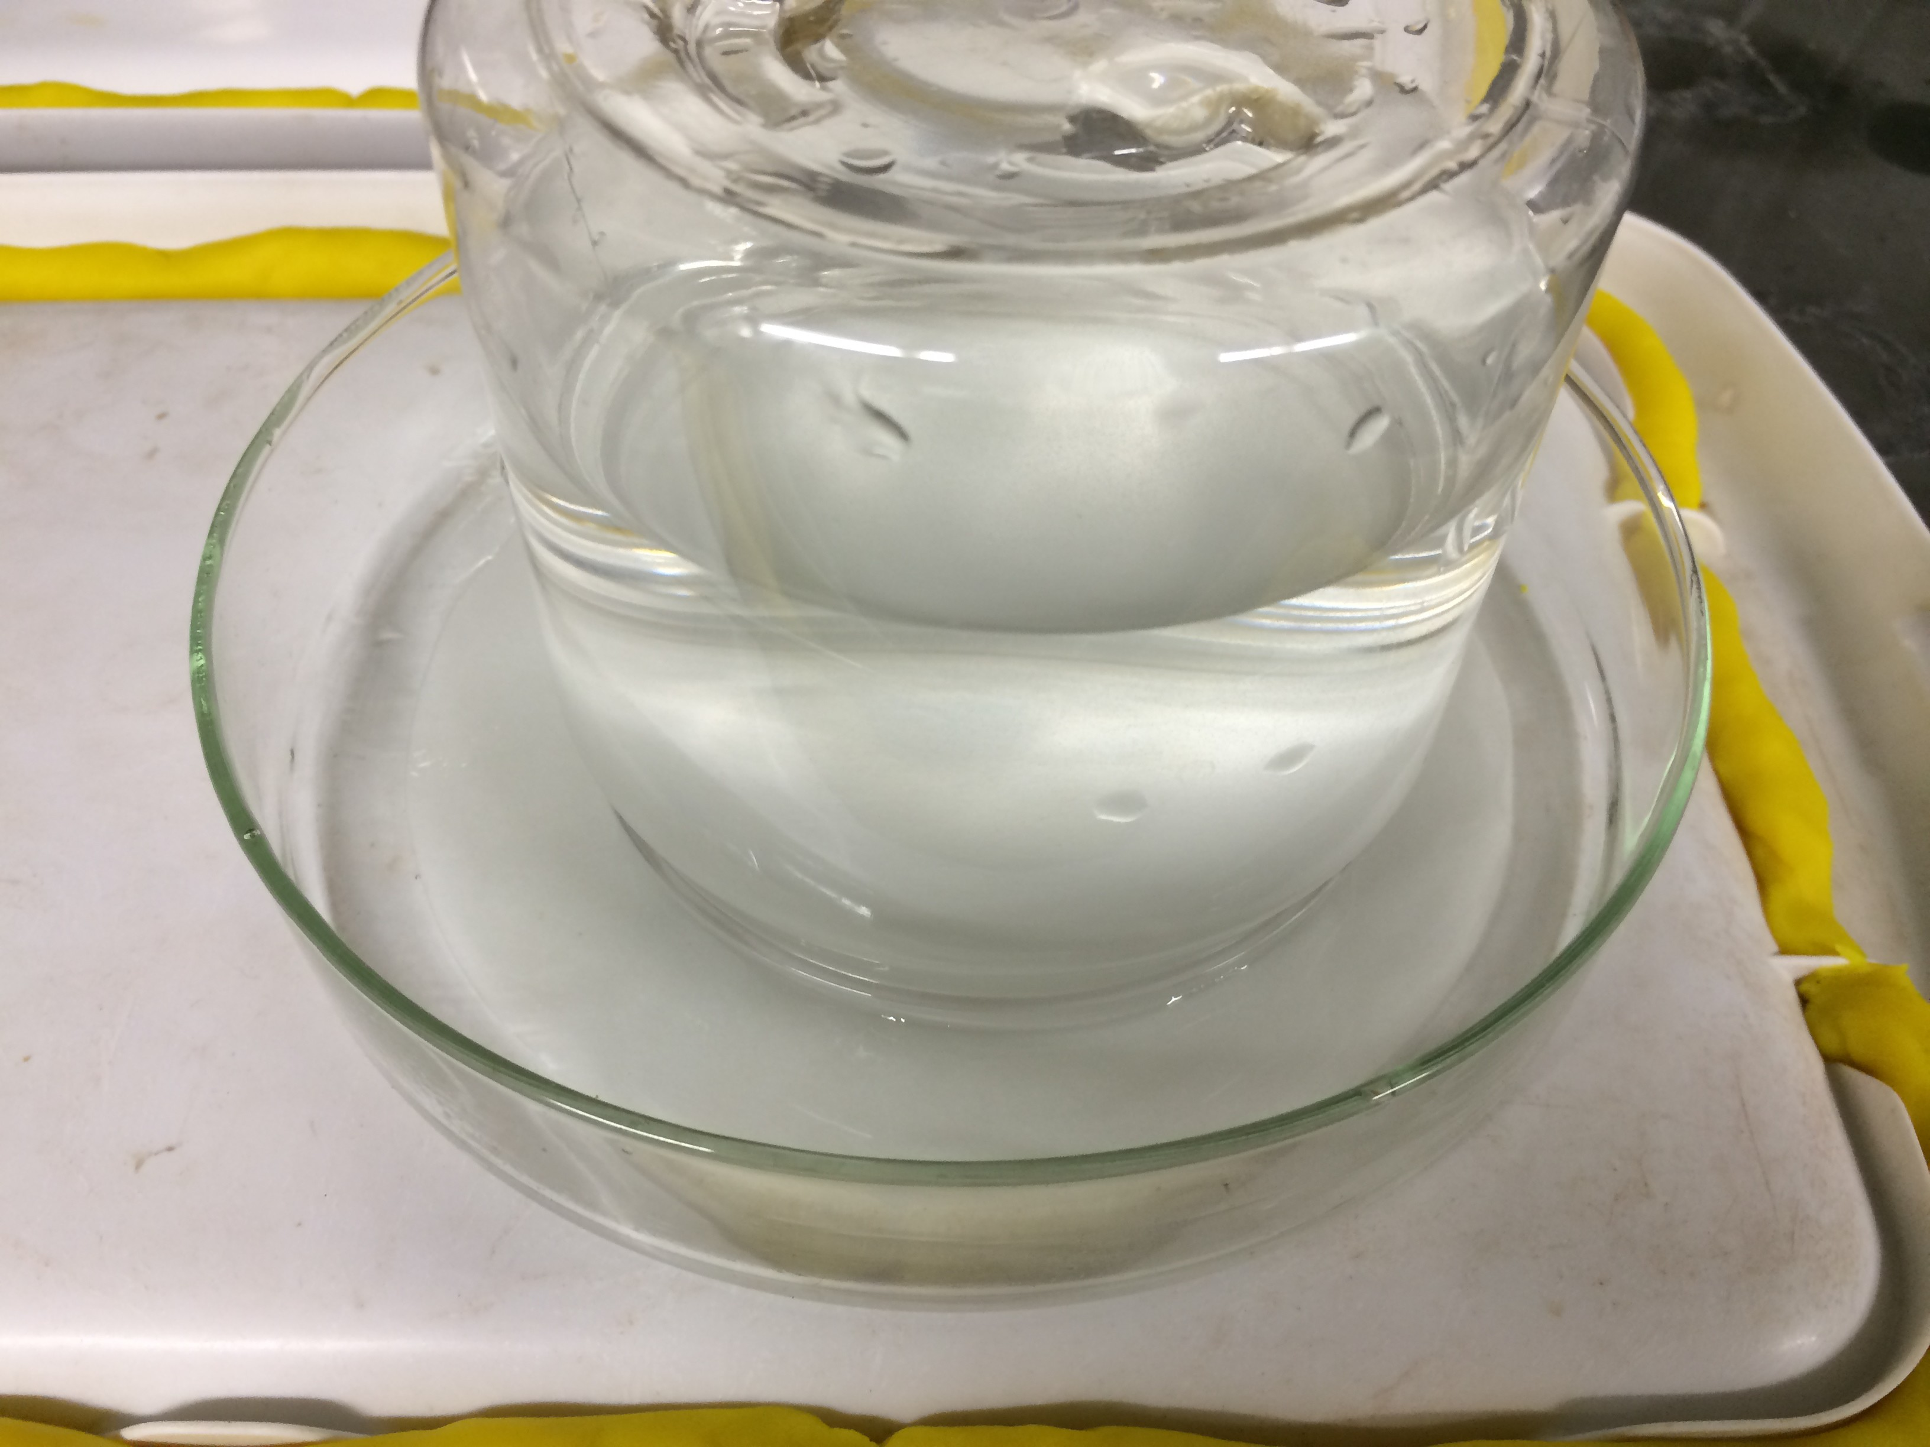6. Place the water sources on the lids, opposite the side with the marking. At this point, the setup should resemble that of the one in the following photo:

7. Using three small petri dishes, weigh out three different amounts of food material.
There should be dishes containing 0.5 grams, 1.0 gram, and 1.5 grams of food.
8. Place the food-containing petri dishes on the marking below each hole. These can be secured with tape or just sat there if the setup will no be moved over the course of the experiment. Label each container with the amount of food it contains.
9. Once the food and water are in place, the container can now be securely snapped
into the lid. The modeling compound should flatten under the container and be extruded on either side of the container wall.
10. Take more modeling compound (such as Play-Doh), and pack it into the lip of the lid. This will make for a more secure seal between the lid and the container. Fill up the groove to at least make it even with the wall of the lid. It can also be built up as to taper as it goes up the wall of the container as in the photo below:
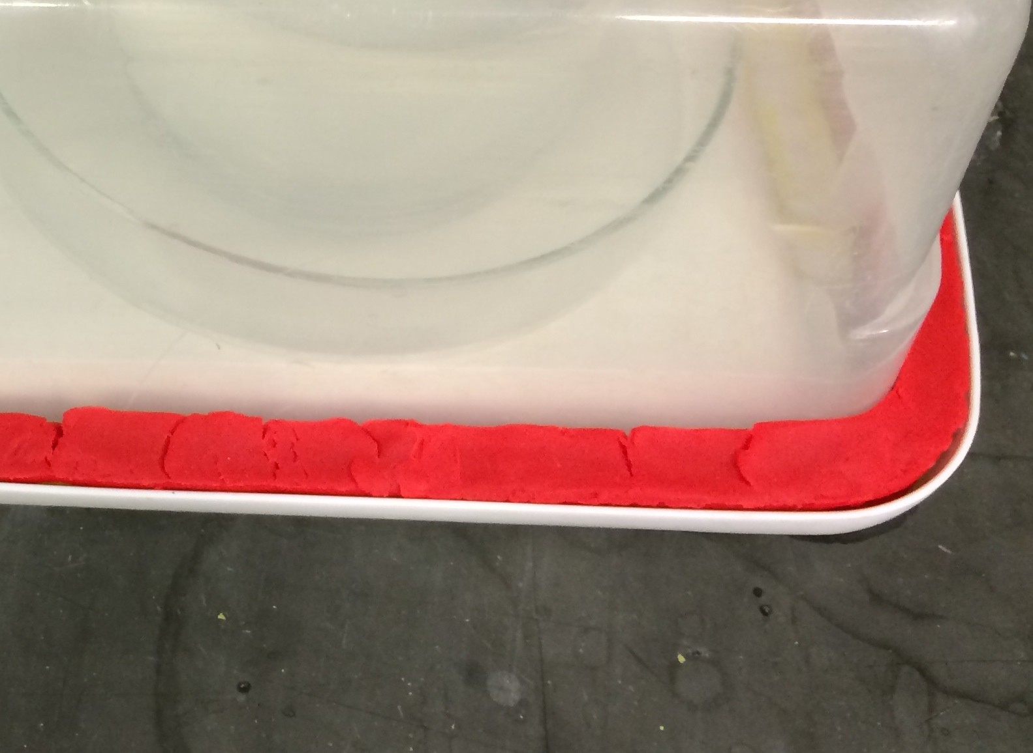

11. Using three cotton balls, seal the small hole cut in each container. The cotton ball should allow gas exchange without allowing the flies to escape.
12. Using CO2, anesthetize a large vial of CS flies.
13. Either with a microscope, magnifying glass, or naked eye, determine the sex of
each fly and place them in piles accordingly. In order to sex each fly, you must be

familiar with the characters that distinguish the two sexes. Please see the sex- determining guide online for more information.
14. Using a pair of forceps, place one male and one female in each container via the small hole. Take special care not to drop them in the food directly beneath the
hole. Doing so may result in them getting stuck in the food.
15. Plug the hole back with cotton.
16. Over the course of the next hour, ensure both flies wake up and are mobile. If either fly is not responsive, it must be replaced with another fly of the appropriate sex.
17. The final setup should resemble that of the one in the following photo:

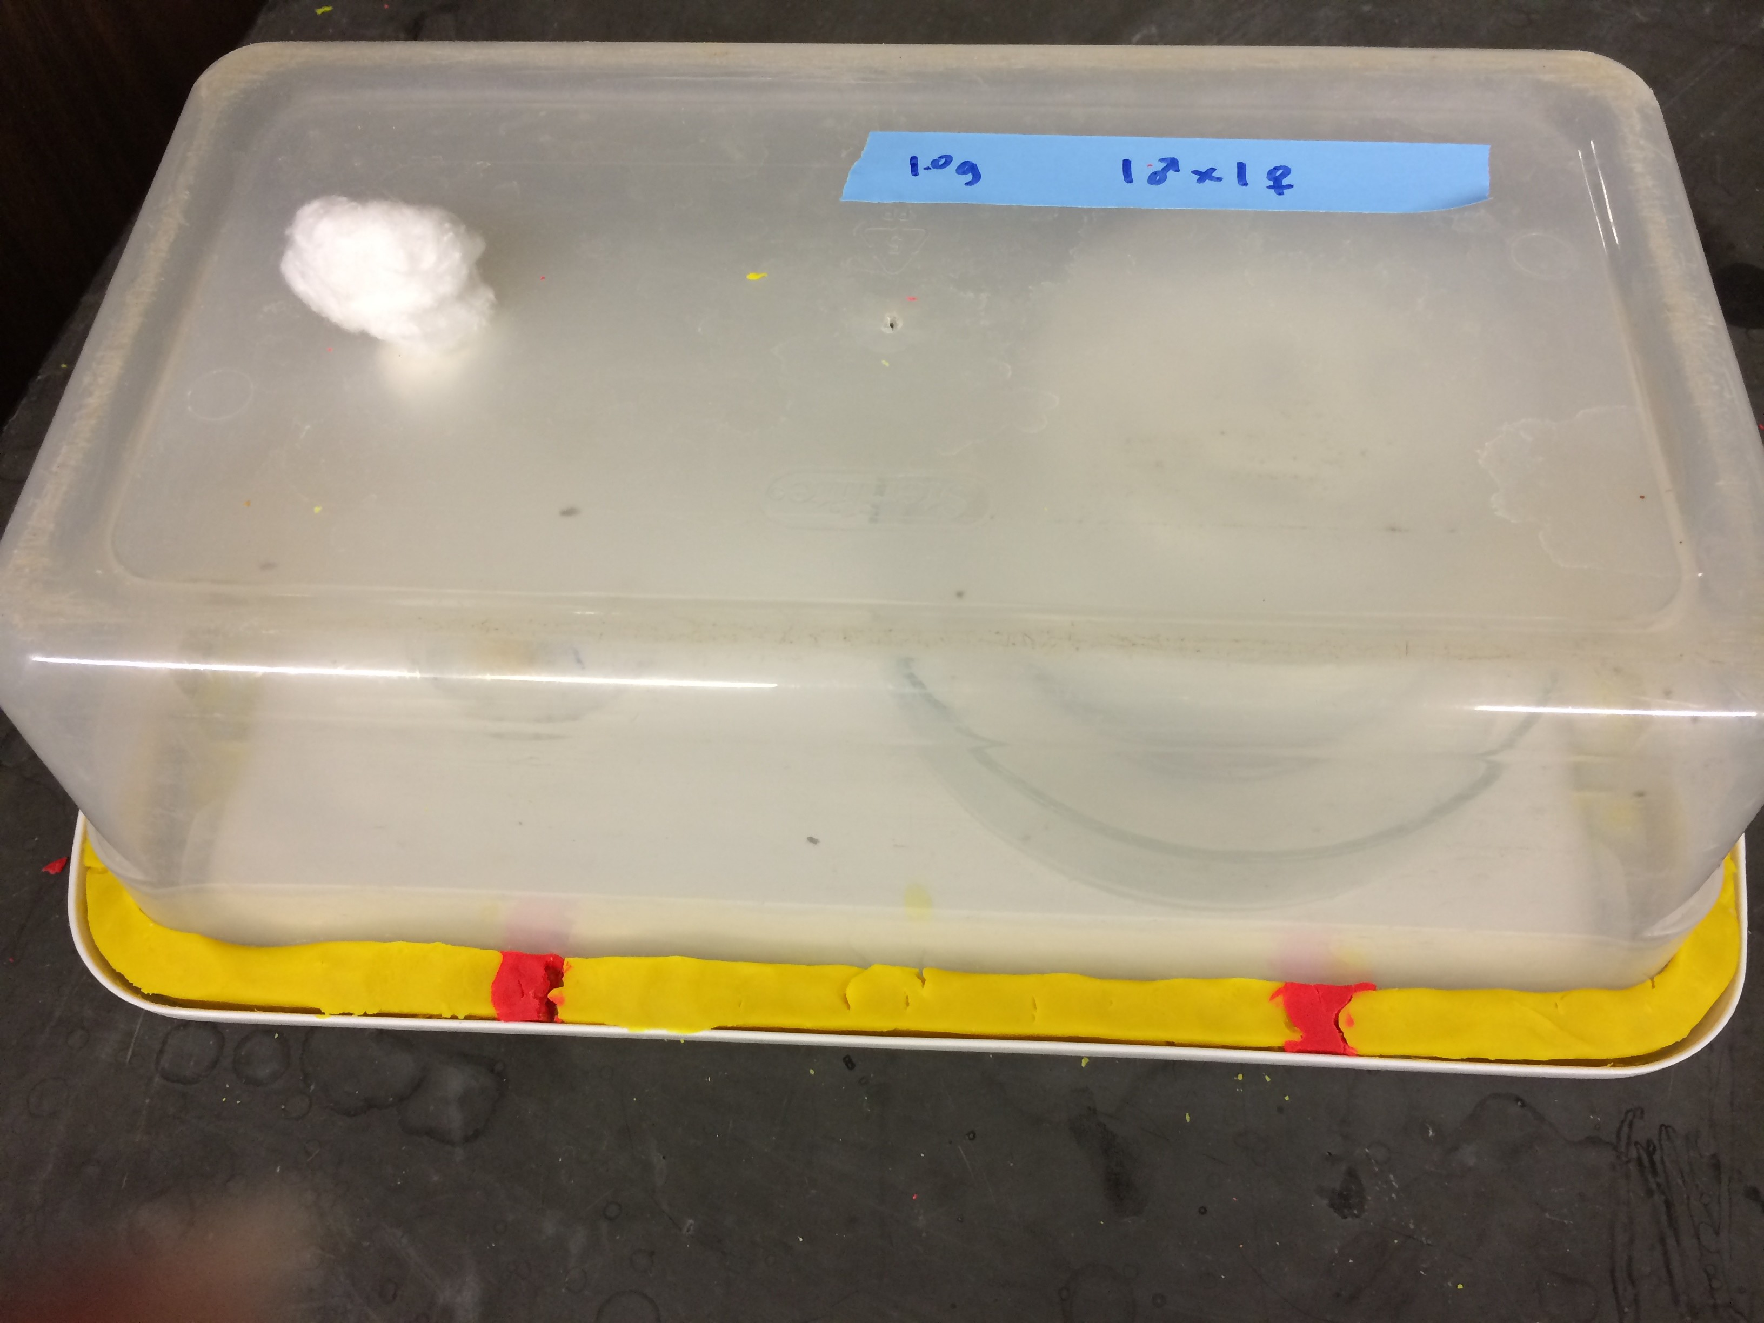

18. The food in the three containers has a tendency to dry out. Therefore, a few drops of water should be squirted through the small hole onto the food every two to three days. It is important not to flood the petri dish but moisten the food. This can be done with a syringe, pipette, or squirt bottle, but be careful not to let any flies escape.
19. Sometimes the modeling material will dry up and retract from the container. Any voids should be periodically filled in with more modeling material.
20. At the time the food is moistened, the container should be checked for signs of life. If any fly appears to be alive, leave the container alone and check back in a
few days. Growth of mold is normal, and the experiment shouldn’t be halted at signs of growth within the container. Once all flies appear dead, move on to the
data collection stage.

Collecting Data from Populations in Large Containers:
1. Once all of the flies in a container have died, the container is ready to be counted.
The data can be collected as containers die out, or all of the containers can be saved until the last population dies. This can take eight weeks or longer.
2. The containers must be opened. Start by removing the dry modeling material from the lip of the lid. This can be discarded or saved to be rehydrated.
• If you are going to rehydrate the modeling material, line a large container (similar to the one housing the flies) with paper towels. Moisten the paper towels with water. Place the dried modeling material into the container. Place more moistened paper towels over the dried modeling material, and secure a lid to the container. After approximately a week, the modeling material should be rehydrated and reusable.
3. With the modeling material out of the way, snap the container off of the lid. After this point, dead flies can be anywhere. They can be in the food petri dish, the water petri dish, the modeling material exposed to the interior, and on the bare plastic of the lid. Take special care not to prematurely remove any flies.
4. In a data table, record the number of dead adult flies in each container. Do not mind any eggs, larvae, or pupa that may also be dead. Check every component of the setup for adult fly carcasses. Sometimes, especially in the food dish, it can be difficult to discern what is an adult fly. Use your best judgment when counting. Below is a photo of a portion of the lid after the experiment had concluded. Pay special attention to the green mold and the amount of flies dead in the food:

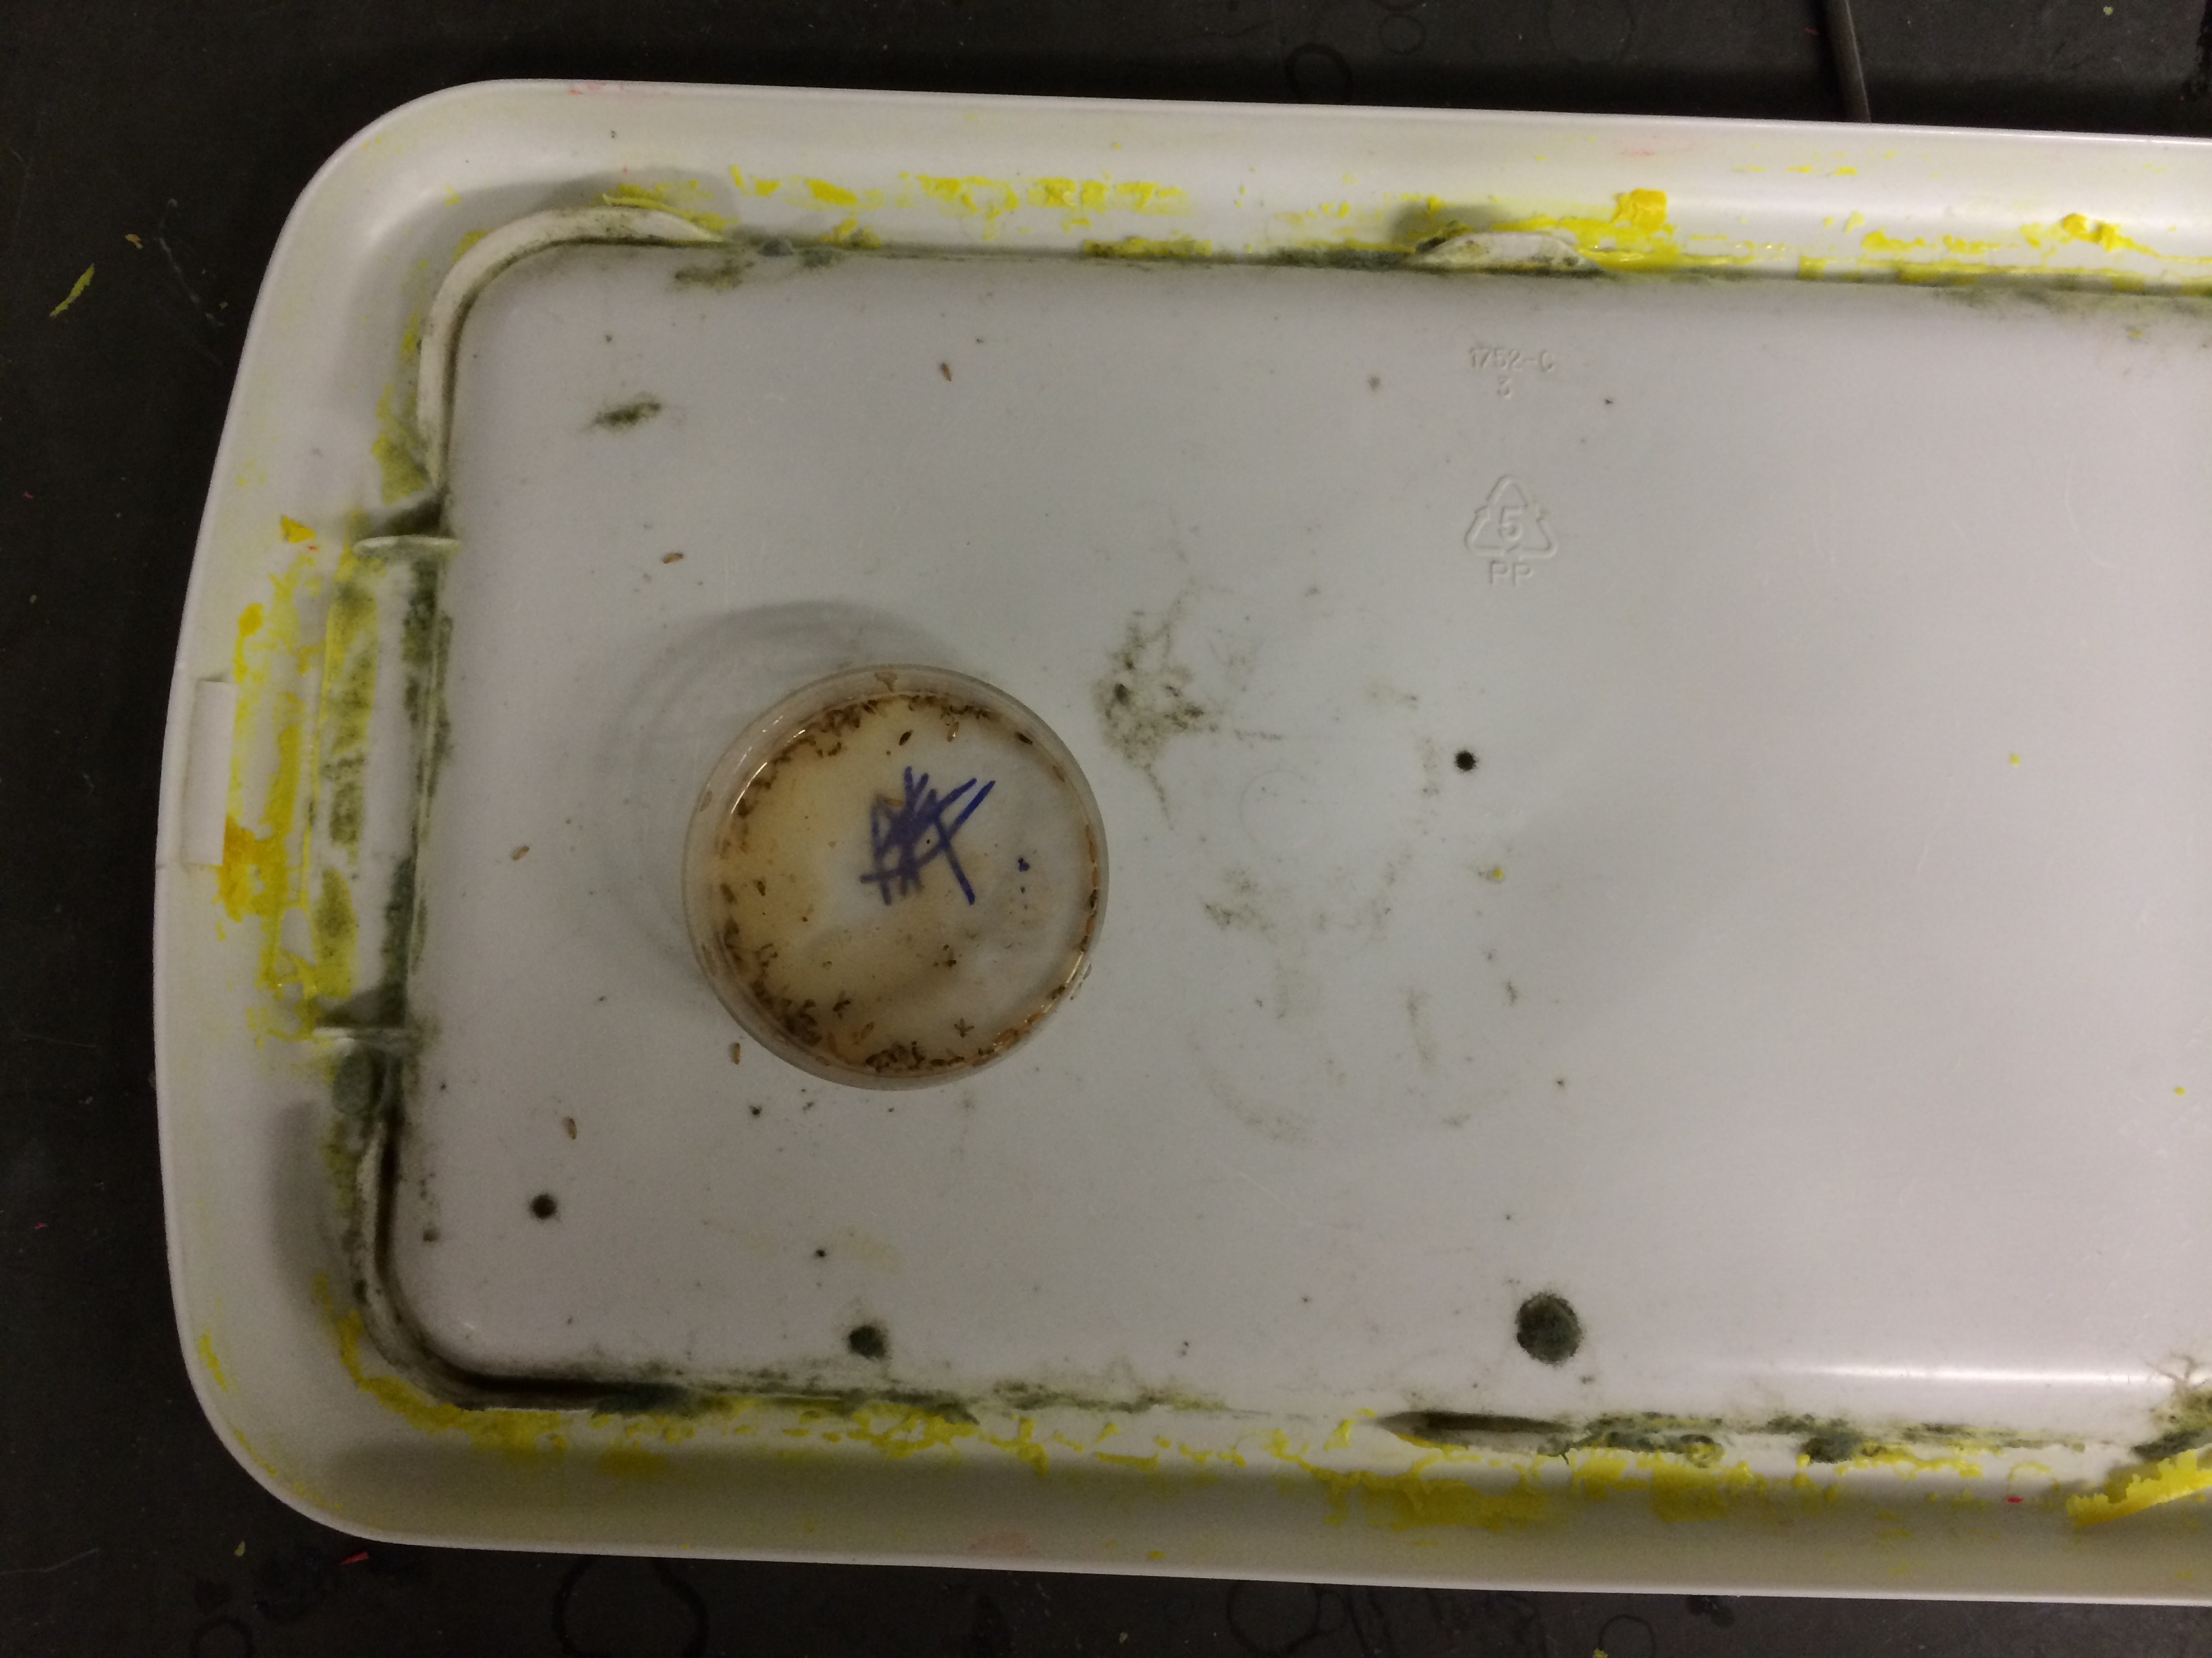

5. After all containers have been opened and counted, thoroughly clean each component with soap and water.

Data Analysis
Now, you should have data about how large each population grew before it died
out. This section will give step-by-step instructions on how to analyze this data. It will require the use of one computer program (Excel). Ultimately, we will be making a graph and using it to draw basic conclusions.

Using Excel to Visualize Data:
1. Upon completion of data collection, you should have a table containing the
number of dead adults from each food treatment level. This data should be imported into Excel. Please visit the module website (included on the first page) to download the template. Below is a screenshot of what the worksheet will contain. (Note: screenshots are taken on a Macintosh running Excel 2011. Some items and options may appear differently on your computer):
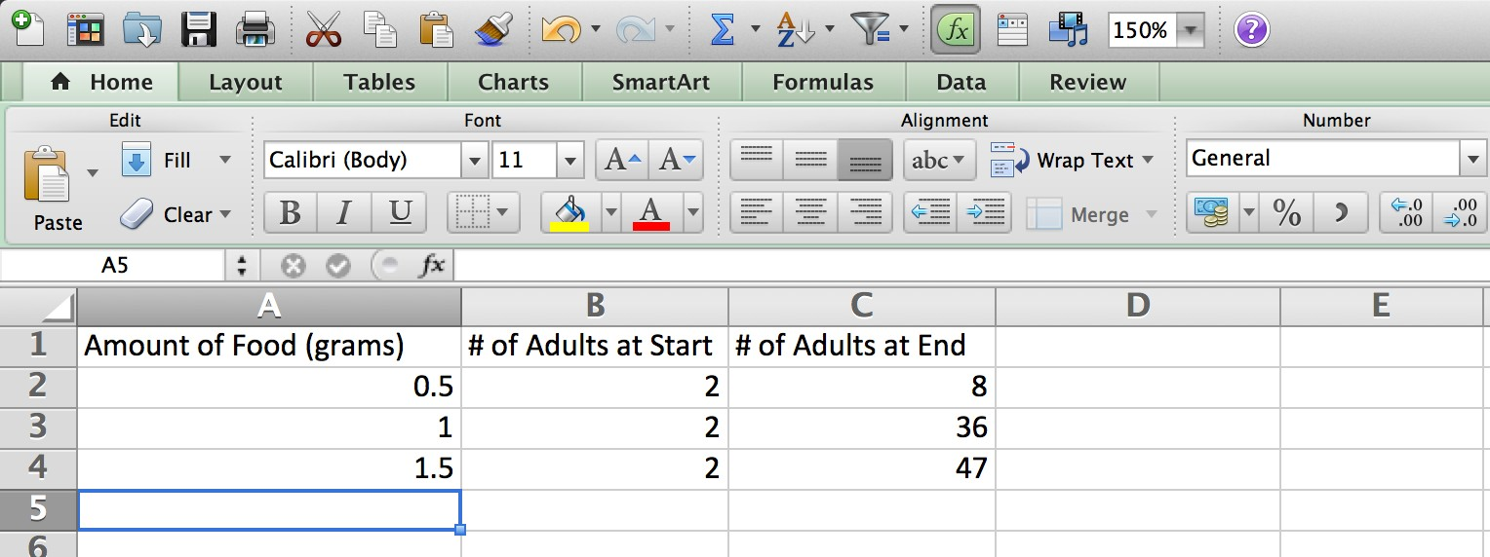
2. When you open the template, you will notice that there are three columns, two of which have already been filled in. Please add your data to the third column of the spreadsheet.
3. Now, we will use Excel to make a graph from the data. This process varies widely between versions of Excel. These steps will hopefully be generic enough to apply to any recent version.
4. Select the data, and go to the “Charts” tab on the ribbon. Go to “Column” then “2- D Clustered Column” as seen in the image below:
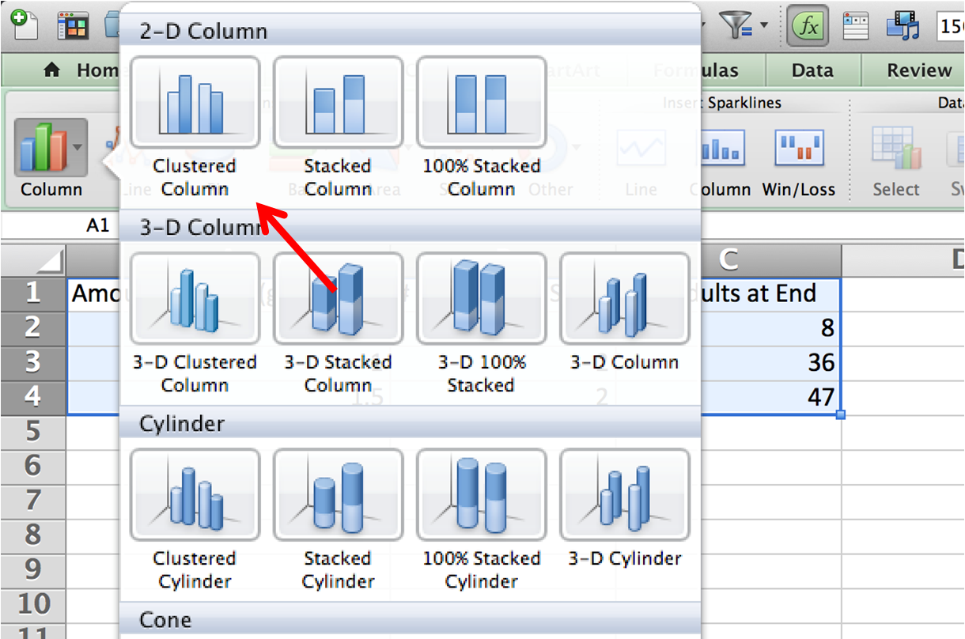

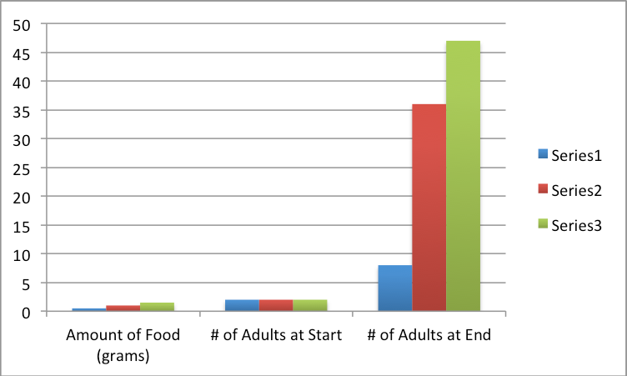5. That will produce a graph from the data. It is likely, however, that this graph doesn’t actually display the information we are interested in. We will have to edit this output to suit our needs. Look how the graph made is not exactly useful:

6. Right click the graph that Excel made and click “Select Data.”
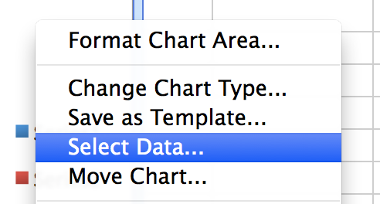
7. The corrections to be made will depend greatly on which version of Excel you are using. If the options used in the following steps do not appear on your computer, look for options with similar functions. In the dialog box, start by hitting “Switch Row/Column.”
8. In the series section, remove the series dealing with amount of food.
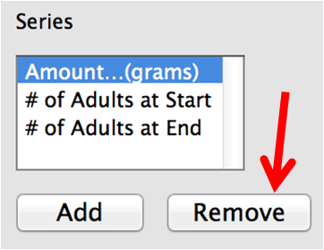
9. For the field for “Category (X) axis labels,” click the small button to the right of the box with the arrow in it.

10. This will open up a selection tool to be used to define the Categories for the graph. Using the tool, select the three food amounts and press enter/return.
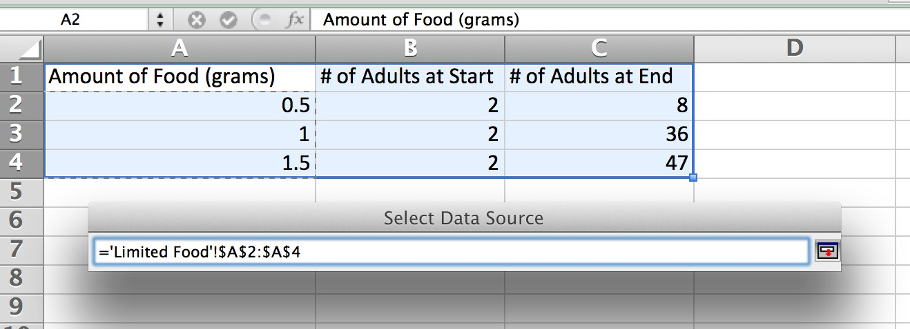
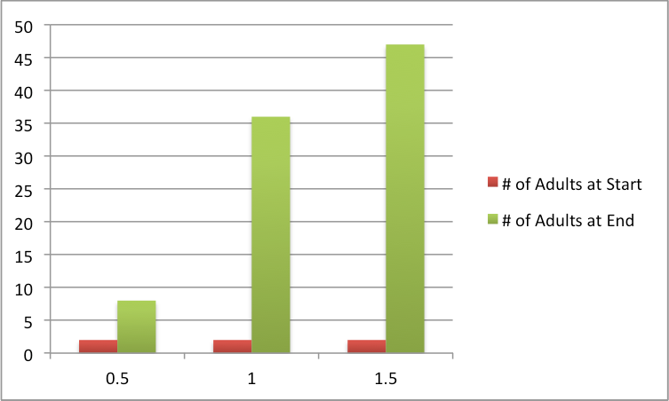11. Clicking “OK” should yield a much better graph. It should be similar to the one seen below:

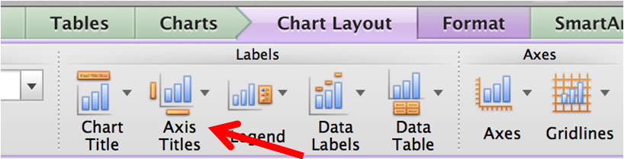12. Though much better, this graph still needs to have proper labels applied. Go to the “Chart Layout” tab of the ribbon, and locate an option to edit axis titles similar to the one below.

13. Add appropriate labels to both the horizontal and vertical axes. They should correctly identify the thing being counted with the correct units.
14. Now add an appropriate title to the graph. The option for adding a title to the chart
is usually found near the option to add axis titles.

the following graph. Please note that aesthetic differences are not important, and differences in labels/titles are fine as long as they convey the same information.
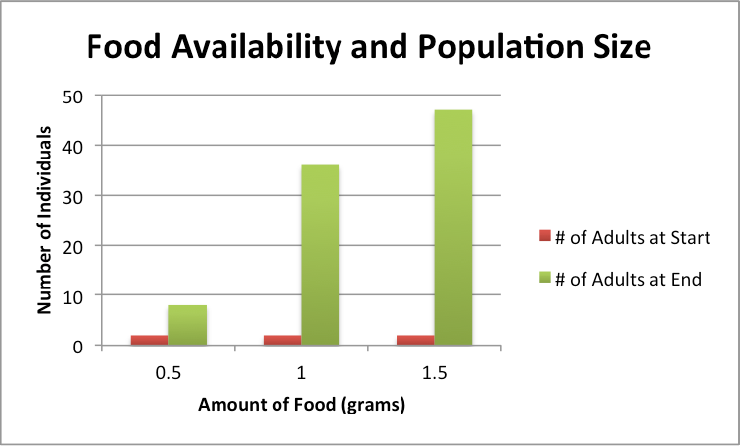

Reading Excel Graphs:
1. At this point, you should have successfully created a graph in Excel that depicts how population size varies with food availability. Please pull up that graph, for it will be necessary to complete the following sections.

2. Let’s start by comparing the bars on the graph. Between the three categories, discuss differences in height, how height changes as more food is available, and overall number of individuals.

3. For each category, there should be two bars. One represents the population of adults at the beginning of the experiment, and the other shows the number of
adults at the experiment’s conclusion. Find the difference between the starting and ending population for each food amount. This represents how much each
population grew.

Drawing Conclusions
At this point, you have formed a hypothesis related to how amount of food
available impacts population size, collected data from an experiment to test that hypothesis, and analyzed the data to make it easier to draw conclusions. Now it is time to build on everything you’ve done and draw conclusions from the analysis. Review your responses to the questions in the “Reading Excel Graphs” section.

Conclusion questions:
1. Is there a relationship between amount of food available and how large a population can grow? If so, what is it?
2. Does this observed relationship support or refute the hypothesis from earlier?
Why or why not?

for food?

Challenge questions:
1. This experiment assumes that each populations dying out is caused by the exhaustion of available food. What other factors may have caused a die off? How would a premature die off skew the results?
2. From the experimental procedure, recall that the food would occasionally dry
out and water had to be periodically added to moisten it. What affect would the food constantly changing consistency have on the population? Please consider where flies stay predominately during different stages or their life cycle. How could allowing the food to get too dry or making it too wet change the results?
3. Earlier in the module, we examined how the initial population size impacted
how quickly a population grew. If this experiment were repeated with four initial adults (one male and three females) instead of two, what would change? Would the final population size be larger, smaller, or the same? Would the die out occur sooner, later, or at the same time? Explain your conclusions.

